http://www.huffingtonpost.ca/2012/05/22/nunavut-natural-resources-province_n_1536770.html

Nunavut Natural Resources: Feds Discuss Province-Like Powers For Territory
CP | By The Canadian Press Posted: 05/22/2012 1:50 pm Updated: 05/23/2012 3:48 pm
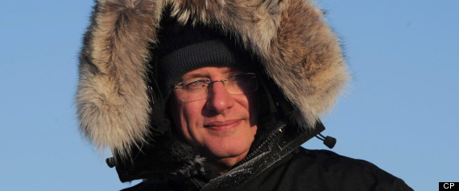
Follow:
Nunavut, Nunavut a Province, Nunavut Becoming Province, Nunavut Minerals, Nunavut Mining, Nunavut Natural Resources, Nunavut Province, Nunavut Resources, Nunavut To Be Province, Canada Politics News
IQALUIT, Nunavut - Ottawa and Nunavut are opening talks on granting province-like powers to the eastern Arctic territory over its natural resources.
"Our economic development and our self-reliance depend on reaching an agreement to transfer land management responsibilities to Nunavut," Pemier Eva Aariak said Tuesday as she named Nunavut's chief negotiator for the talks.
The territorial government currently doesn't collect any royalties from resources on its land. The money all flows to the federal government. Ottawa also has regulatory authority for the development of those lands.
All Nunavut governments have maintained that getting a share of the potential wealth from the territory's rich deposits of gold, uranium, iron and other resources are the key to weaning itself off its abject dependence on federal transfers. Mining companies spent more than $300 million in 2011 alone on exploration and development in the territory, which currently has one gold mine in operation and other major projects in the pipe.
Nunavut Tunngavik Inc., which manages the Nunavut land claim, will also be at the table.
Years of negotiations are likely to follow. But the outlines of a settlement may already be clear.
Observers have suggested the territory is likely to be offered a deal similar to the one signed by the Northwest Territories last year. The Yukon, which signed its resources deal in 2003, immediately asked Ottawa to match the N.W.T.'s agreement.
Top of Form
Bottom of Form
"(Nunavut) might wonder how much negotiating room really remains," wrote former senior Nunavut finance bureaucrat Anthony Speca in an analysis in the latest Policy Options journal.
Under the N.W.T. deal, which is opposed by many of the region's aboriginal leaders, that territory will receive 50 per cent of resource royalties up to the equivalent of five per cent of its overall expenditures. Royalties over the five per cent level will be clawed back from the territory's total federal grant.
In 2010, the N.W.T.'s expenditures were about $1.2 billion, which would allow for the jurisdiction to collect up to $60 million in resource royalties.
As well, the N.W.T. failed to win jurisdiction over its offshore resources, which will remain under federal control.
Still, Nunavut's deal will have to take into account the territory's particular circumstances, said territorial spokeswoman Emily Woods.
"A devolution agreement for Nunavut must be consistent with the Nunavut Land Claims Agreement and address our distinct situation," she said.
Some Nunavut residents are already benefiting from resource royalties. The Nunavut Land Claim gave Inuit surface and subsurface rights to an amount of land roughly equal in size to Germany. Royalties from those lands are already starting to flow to Nunavut Tunngavik and are expected to total hundreds of millions of dollars over the next generation.
However, that money is expected to be used to benefit Inuit, not to pay for programs and infrastructure for the territory as a whole.
In 2007, a paper commissioned by the federal government advised against transferring control over lands and resources to the government of Nunavut, concluding that the territorial administration didn't have the staff or the skills to do the job.
Aariak said Tuesday those concerns are no longer relevant. She pointed out that Ottawa has agreed to help Nunavut develop its management capacity in tandem with the negotiations, and that the territory has a larger reservoir of trained Inuit than it did five years ago.
"The number of young people that are getting ready through education and employment and training, it will be that much easier to discuss the capacity issue in parallel with the negotiation," she said.
— By Bob Weber in Edmonton

